

# Student Dashboard

The attached CSV document contains a collection of student records. Each record has the following fields:

* Name – The first name of the student.
* Surname – The last name of the student.
* Is Class Leader – Each grade has one class leader.
* Grade – The current grade the user is in (8 - 12).
* Subject – The name of a school subject.
* Score – The percentage score the student received for the relative subject.

Each numerical score can be translated to an alphabet character:

|  |  |
| --- | --- |
| Score Range | Alphabet Character |
| 0-9 | J |
| 10-19 | I |
| 20-29 | H |
| 30-39 | G |
| 40-49 | F |
| 50-59 | E |
| 60-69 | D |
| 70-79 | C |
| 80-89 | B |
| 90-100 | A |

If a student scores below 50% for a subject, the student fails the subject.   
If a student fails English, or any other two subject, the student fails the year, and he/she will need to repeat the grade.  
If a student fails Mathematics, and one other subject, the student fails the year, and he/she will need to repeat the grade.  
Class leaders automatically get 10% added to every subject score. They cannot get more that 100% for a subject.

# Questions

1. Create a console application to read the student information into C# objects.  
   **Bonus points** if you can specify the file location to the console application when executing it.  
   **Warning** The CSV is slightly “broken”. You code needs to be able to handle the “broken” file. **Don’t** fix the CSV file.
2. Allow to user to input one, or many additional student records (The user will decide when they have added enough student records).  
   **Bonus points** if you have proper validation on the input values.
3. The application needs process and group the student records, and store the processed records to separate CSV files:
   1. The students need to be grouped per **Grade**
   2. Each **Grade** will have 3 folders:
      1. All Students: A CSV file for each student containing the following fields:
         1. Name – The first name of the student.
         2. Surname – The last name of the student.
         3. Is Class Leader – Each grade has one class leader.
         4. Grade – The current grade the user is in (8 - 12).
         5. Subject – The name of a school subject.
         6. Score – The percentage score the student received for the relative subject.
         7. Alpha Score - The alpha character representing their score.  
            **Below above values, the following information needs to be displayed:**
4. The Average of all the subjects.
5. The subject with the highest score (and its related score).
6. The subject with the worst score (and its related score).
7. Whether or not the student has passed or failed.
   * 1. Top Achiever: Place a CSV file of the student with the highest average for all his/her subjects in this folder. The contents of the CSV should be the same as the **All Students** CSV file.
     2. Worst Achiever: Place a CSV file of the student with the lowest average for all his/her subjects in this folder. The contents of the CSV should be the same as the **All Students** CSV file.

Here is an example of the folder structure you need to create:  
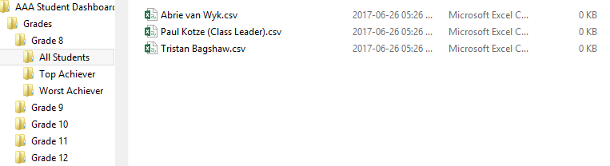

1. The following summary information should be displayed on the screen:
   1. A grid with the following information:

|  |  |  |  |
| --- | --- | --- | --- |
| Grade | Best Subject | Worst Subject | Avg Score |

Here is an Example:

|  |  |  |  |
| --- | --- | --- | --- |
| Grade | Best Subject | Worst Subject | Avg Score |
| 12 | English | Mathematics | 60% |
| 8 | Mathematics | Afrikaans | 40% |
| 11 | English | Computer Science | 30% |
| 9 | Afrikaans | Afrikaans | 20% |
| 10 | Computer Science | English | 10% |

The information in the grid should be ordered from the highest Avg score to the lowest average score.

* 1. The best subject across all grades.
  2. The worst subject across all grades.
  3. The best student across all grades.
  4. The worst student across all grades.